**INVITATION TO BID FOR THE PUBLIC BIDDING FOR UNSERVICEABLE PROPERTIES AND WASTE MATERIALS**

**28 December 2020, 1 p.m.**

**NCCA Gallery**

**INVITATION TO BID**

1. The National Commission for Culture and the Arts (NCCA), through the Disposal Committee (DC) hereby invites all interested parties to participate in the public bidding of the following lots on an “As-is Where is” basis as indicated below:

|  |  |  |
| --- | --- | --- |
| **ITEM/DESCRIPTION** | **LOCATION** | **FLOOR PRICE** |
| **Lot 1. UNSERVICEABLE PROPERTIES**  (Various Office equipment, Information and communication technology equipment (ICT), Communication equipment, Furniture and Fixtures, Technical and Scientific equipment, and Other PPEs) | **NCCA Parking Area** | **P 73, 000.00** |
| **Lot. 2. WASTE MATERIALS**  Various defective office supplies, defective cellphones, defective smoke detectors, defective fire alarms, defective spotlights, defective assorted wires, used carpet, used/damaged venetian blinds and other metal scraps | **NCCA Parking Area** | **P 7, 500.00** |

2. No bid shall be allowed lower than the said floor price.

3. The interested bidder may **view and inspect the items at 633 General Luna St. Barangay 658, Intramuros, Manila on December 18-27, 2020 from 8am-3 pm**. Please be reminded that interested bidder/s should coordinate with Ms. Alba or Ms. Pamulaklakin (028 527 2192 local 211) of the Supply and Management Section.

4. Interested bidders may get the bid documents from any representative of Supply Management Section (SMS), Room 2E, NCCA Building. Sealed bids will be received by any representative from Supply Management Section (SMS) **on December 28, 2020 from 9am – 12 noon only**. Late bids will not be accepted. The bidder (company owner or representative) shall enclose in separate envelopes the following:

* **Fully-accomplished Bid form**
* **Minimum cash bond/deposit equivalent to ten percent (10%) of his/her bid price.** It will be considered as a deposit for the winning bidder and may apply it for the lot he/she purchased. While cash deposit of non-winning bidder/s will be returned right after the Opening and Awarding of Bids.
* **Photocopy of the company’s latest Mayor’s permit;**
* Latest Notarized Special Power of Attorney (in case the duly authorized company representative is attending the public bidding).

**The sealed bid form with cash deposit should be marked as follows:**

**TO: HERENCIO Y. LLAPITAN**

Head, Technical Working Committee

NCCA Disposal Committee

**FROM: <NAME OF BIDDER>**

Address of the Bidder

Contact No. of Bidder

**RE:** <Lot No. and Lot Description >

5. The company owner or their designated company representative must be present (physically present at the venue or present online) during the opening of the bids, otherwise, the sealed envelope shall not be opened.

6. The bid shall be declared void if it does not comply with the abovementioned requirements. Prior to the issuance of the Notice of Award, the winning bidder shall **present the original copy of the foregoing documents for validation**:

* Any Government Issued card (e.g. Driver’s License, Postal ID, Passport, GSIS/SSS Card or company ID
* Acknowledgement Receipt of Bid Bond/Cash Deposit

7. **Opening of bids will be held on 28 December 2020 at exactly 1 pm at NCCA Gallery/via Zoom. Zoom link will be provided to all the bidders who successfully submit their sealed bids.** Bids will be opened in the presence of all the bidders or their duly designated representatives and the NCCA Disposal Committee and COA representative/s.

8. After registration, **the Participation fee of 1, 000 is non-refundable whether the interested bidder is able to submit his/her sealed bids and cash deposit or not. Participation fee of the winning bidder shall not be added to his/her bond/cash deposit.**

9. The **bid bond shall be forfeited if the full price is not paid by the winning bidder within three (3) working days after receipt of the NOA**. In this case, the NOA will be given to the next winning bidder.

10. Upon payment of the full price, the winning bidder shall be the recipient of the waste material and is required to haul (all expense shouldered by the winning bidder), **within five (5) working days**.

11. **Full payment shall be required upon the schedule of hauling**. Failure to haul the unserviceable properties and waste materials within the specific period of time will result to forfeiture of their payment will be offered to the next winning bidder.

12. The invitation to bid will be posted in at least three public places. The NCCA Disposal Committee reserves the right to reject any or all of the bids, with or without cause, to annul the bidding process, to waive any defect in them and to award the bidder whose bid is the most advantageous to the agency/government.

13. For queries or further information, please refer to:

**SHERYL A. ALBA**

AO1-Supply Management Section

Room 2E, 2nd Floor, NCCA Building

633 General Luna St.

Intramuros, Manila

Telephone: (028) 527-2192 local 211

Email:shealba@yahoo.com.p**h**

**TERMS, CONDITIONS, RULES AND PROCEDURES FOR THE PUBLIC BIDDING OF WASTE MATERIAL IN METROPOLITAN THEATER**

**Opening Date:** 28 December 2020

**Venue:** NCCA Gallery

1. **Caveat Emptor.** All units shall be sold on an “AS–IS, WHERE–IS” basis.

2. **Reservation Clause.** NCCA, as the auctioneer, including its employees (except the Members and Secretariat of the NCCA Disposal Committee) reserves the right to bid on any unit.

3. **Requirements.** During the opening date, the interested bidder/s (owner/representative) shall present the original copy of the following to the Registration desk:

*3.1. Any Government Issued card (e.g. Driver’s License, Postal ID, Passport, GSIS/SSS Card) or company ID*

*3.2. Acknowledgement Receipt of Participation Fee*

* 1. Photocopy of the company’s latest Mayor’s permit;
  2. Latest Notarized Special Power of Attorney (in case the duly authorized company representative is attending the public bidding).

4. **Cash Deposit.** Before registration, the prospective bidder shall submit the sealed bid form together with Cash deposit minimum of 10% of his/her bid. It will be considered as a deposit & shall be applied to his/her purchase. After registration, the Registration personnel (composed of staff from the NCCA DC Secretariat together with COA Representative as witness shall provide the prospective bidder with an Acknowledgement receipt for the latter’s cash deposit.

**Cash deposit of non-winning bidder/s will be returned after the Opening and Awarding of Bids.**

5. **Participation Fee.** Before registration, the prospective bidder shall pay One thousand pesos if he/she wants to bid. **The participation fee is not refundable.**

6. **Minimum bid.** The minimum bid shall not be lower than the posted government floor price.

7. **The Committees Right and Powers.** The highest qualified bidder recognized by the Auctioneer shall be the buyer. In the event of any dispute between any bidders at the auction, The NCCA Disposal Committee, through the Auctioneer, may at its sole discretion reoffer the unit. The Committee’s decision and declaration of the winning bidder shall be final and binding upon all Bidders. The NCCA Disposal Committee deserves the right to reject any or all of the bids with or without cause, to waive any defect in them and to award the bidder whose bid is the most advantageous to the government.

8. **Complaints.** Any unresolved complaints should be directed to the NCCA Disposal Committee at 633 General Luna St. Barangay 658, Intramuros, Manila.

9. **Notice of Award (NOA).** The winning bidder (buyer) shall be issued a NOA for the unit/lot he/she purchased. The cash deposit (10%) shall be forfeited if the full price of the lot he/she purchased is not paid within three working days after the receipt of the NOA.

10. **Hauling.** Upon completion of the payment, the buyer shall be the recipient of the purchased waste materials and shall be required to haul/transport the same within five (5) working days. **The winning bidder must ensure cleaning of scraps/wastes in the area.** In case the winning bidder failed to do so after several reminders/messages made by the Disposal Committee, the company of the winning bidder will be blacklisted to the next public bidding of the agency.

11. **Expenses.** After the purchase, any expenses incurred shall be incurred by the buyer and will not be shouldered by the NCCA Disposal Committee.

**HERENCIO Y. LLAPITAN**

Head, Technical Working Committee

NCCA Disposal Committee

**LOT 1. UNSERVICEABLE PROPERTIES: Various Office equipment, Information and communication technology equipment (ICT), Communication equipment, Furniture and Fixtures, Technical and Scientific equipment, and Other PPEs**

IT Peripherals

Assorted wires

speakers

Telephones

**LOT 2: Various defective office supplies, defective cellphones, defective smoke detectors, defective fire alarms, defective spotlights, defective assorted wires, used carpet, used/damaged venetian blinds and other metal scraps**

***Old and Defective staplers***

***Old and Defective punchers***

**LOT 2: Various defective office supplies, defective cellphones, defective smoke detectors, defective fire alarms, defective spotlights, defective assorted wires, used carpet, used/damaged venetian blinds and other metal scraps**

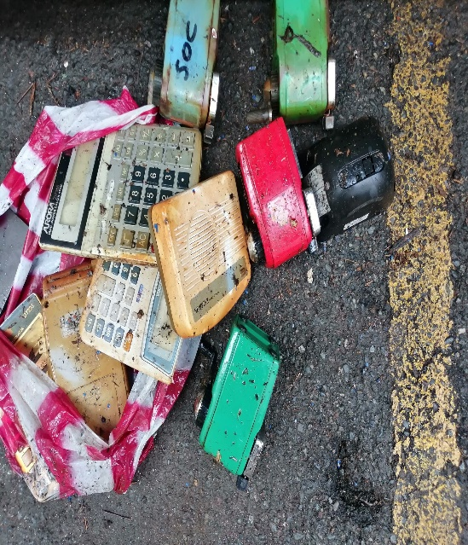

***Defective and old clocks***

***Defective /Old diskette trays***

***Defective Calculators & Pencil sharpeners***

**

***Used/Defective cellphones***

***Used carpet***

**LOT 2: Various defective office supplies, defective cellphones, defective smoke detectors, defective fire alarms, defective spotlights, defective assorted wires, used carpet, used/damaged venetian blinds and other metal**

**scraps**

***Used and defective smoke detector and fire alarms***

***Assorted wires***

***Used and defective spotlights and other scrap metals***

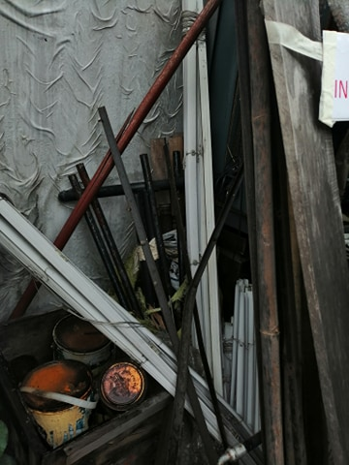

***Used/Damaged Venetian Blinds***